Business Question and Visualization Report

Date | 18 September 2026
Team ID | MCA
Project Name | Smartphone Usage, Digital Addiction & Well-Being Analytic
Maximum Marks | 5 Marks

Visualization development refers to the process of creating graphical representations of data to facilitate understanding, analysis, and decision-making. The goal is to transform complex datasets into visual formats that are easy to interpret, enabling users to gain insights and make informed decisions. Visualization development involves selecting appropriate visual elements, designing layouts, and using interactive features to enhance the user experience. This process is commonly associated with data visualization tools and platforms, and it plays a crucial role in business intelligence, analytics, and reporting
Business Questions and Visualisation
The process involves defining specific business questions to guide the creation of meaningful and actionable visualizations in Power BI. Well-framed questions help in identifying key metrics, selecting relevant data, and building visualisation that provide insights.
What is the distribution of daily screen time among users? | Histogram showing daily screen time distribution | 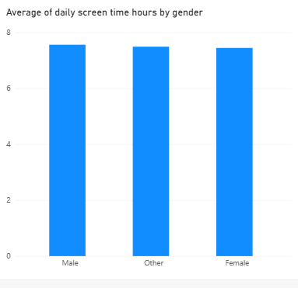
 | Column chart comparing average screen time by age group | 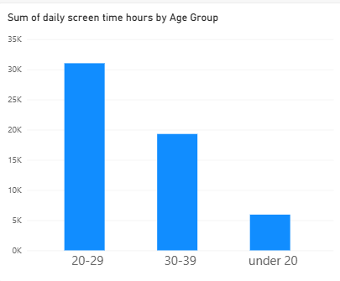
  Which age groups have the highest average daily screen time?
 | Clustered column chart comparing social media and gaming hours | 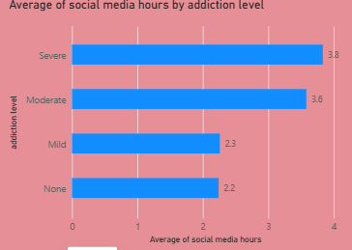
  How does social media usage compare with gaming usage?
What is the relationship between screen time and digital addiction? | Scatter chart showing screen time vs. digital addiction | 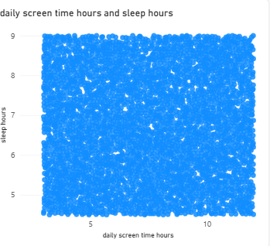
How does stress level vary with digital addiction? | Stacked column chart showing stress level by addiction level | 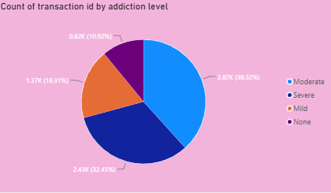
How does smartphone usage affect academic or work activities? | Bar chart showing academic/work impact by addiction level | 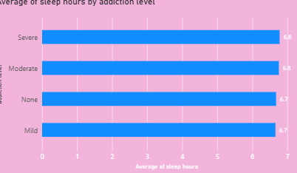
How does weekend screen time compare with daily screen time? | Bar chart comparing daily and weekend screen time | 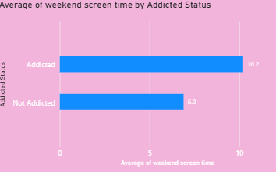
Which user group has the highest digital addiction level? | Bar chart showing users by addiction level | 